**Assignment 20**

**Task 1. Create date and normal slicers on one page to affect visuals on other pages.**

Step 1. Add a new Page and name it as ‘Choices’

Step 2. Add 3 slicer and add following columns in each

Slicer 1- EventDate->Field & Rename Title as ‘Choose a date range’

Slicer 2- ContinentName->Field & Under General->Page Orientation->Horizontal & Rename Title as ‘Choose a Continent’

Slicer 3- CountryName->Field

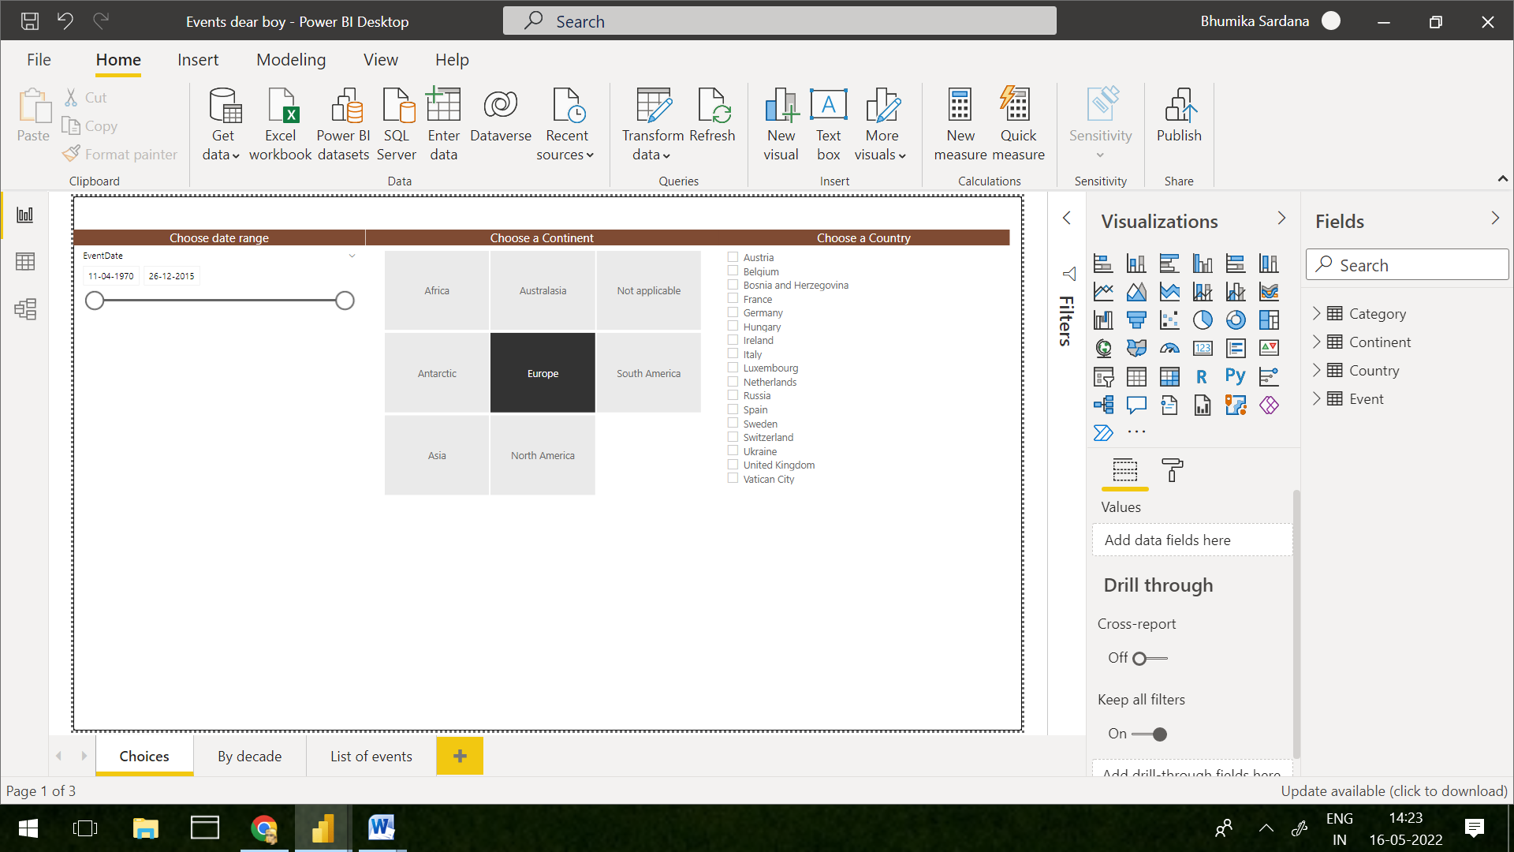

**Task 2. Using the Sync slicers pane, configure your report so that the slicers only appear on the first page, but apply to the other pages:**

**Step 3. Select each slicer and click on SyncSlicer under View and configure each visual as in the below image.**

